JCMS Web Installation Guide

JCMS Web Installer v1.15

JCMS Web v3.14.0

May 2015

Table of Contents

Description 3

Requirements: 3

Instructions 3

Step 1: Download the JCMS Web Installer 3

Step 2: Extract the zip file into a directory 4

Step 3: Launch the JCMS Web Installer 4

Step 4: JCMS Web Installer introduction 5

Step 5: JCMS Web Installation Type 6

Step 6: Install MySQL Community Server 7

Step 7: Configure MySQL Community Server 8

Step 8: JCMS Web Setup 9

Step 9: Installing JCMS Web 11

Step 10: JCMS Web Application Server 12

Step 11: JCMS Resources 14

Starting and stopping JCMS Web 15

Getting started with the JCMS-Web application 17

**Table of Figures**

Figure 1: Extract JCMS Web Installer zip file 4

Figure 2: JCMS Web Installer 5

Figure 3: JCMS Web Installation Type 6

Figure 4: Install MySQL Community Server 7

Figure 5: Configure MySQL Community Server 8

Figure 6: JCMS Web Setup 9

Figure 7: Select an Option 11

Figure 8: Installing JCMS Web 12

Figure 9: JCMS Web Application Server 13

Figure 10: JCMS Resources 14

Figure 11: JCMS Web Command Files 15

Figure 12: A JCMS Web Command Window 16

Figure 13: JCMS Web Welcome Page 16

Figure 14: JCMS Web Accept Security Certificate 17

Figure 15: JCMS Web Application Login 18

Figure 16: JCMS Web Home Page 19

# Description

JCMS Web is a new interface for JCMS providing colony management as a web application. This gives the user a common work experience and greater administration capabilities. The first release of the JCMS Web application offers some basic queries and a report while this second release provides controlled vocabulary administration, account management, and extended mating and litter functionality. JCMS Web is a standalone application although it can run JCMS Access too.

# Requirements:

JCMS Web runs with any version of JCMS greater than version 4.0 running in a MySQL configuration. The computer itself will need to be relatively modern and no more than four years old, and three or more Gigabytes of Memory is recommended. This can be stretched out if the computer you are installing to is a sever class computer. Below is a table that lists the software and the versions that we expect and have tested with.

|  |  |  |  |
| --- | --- | --- | --- |
| **Software** | **Version** | **Where to get it** | **Tested** |
| MySQL | 5.1 | http://dev.mysql.com/downloads/mysql/ | Yes |
|  | 5.5 | http://dev.mysql.com/downloads/mysql/ | Yes |
|  | 5.6 | http://dev.mysql.com/downloads/mysql/ | Yes |
| Java 6 | 1.6 | <http://java.com> | Yes |
|  | 1.7 | http://java.com | Yes |
| Windows | 7 | <http://www.microsoft.com/> | Yes |
| OSX | 10.5 | [http://www.apple.com](http://www.apple.com/) | Limited |
| Linux Kernel | 2.6.x | Fedora Core 14  <http://fedoraproject.org/>  Open SuSE 11  <http://www.opensuse.org/> | Limited |
| JCMS Access | 6.1.8 | <http://colonymanagement.jax.org/> | Yes |
|  |  |  |  |

Table : JCMS Web Requirements

# Instructions

## Step 1: Download the JCMS Web Installer

Download JCMS Web from http://colonymanagement.jax.org/products-2/jcms-web/

## Step 2: Extract the zip file into a directory

Once the file is downloaded you will need to extract the file into a directory. In Windows this is typically done by right clicking on the file and selecting “Extract all”. This will prompt you for a location to unzip the archive.

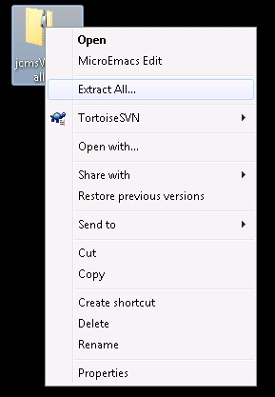

Figure : Extract JCMS Web Installer zip file

## Step 3: Launch the JCMS Web Installer

Typically Windows with Java is set up to run the JCMS Web Installer simply by double clicking on the file JCMSWebInstaller.jar in the directory you extracted the zip file. If for some reason it doesn't execute you can create a script or associate the extension .jar to run the following command. Open a command window or terminal, change directory to the JCMS Web Installer directory and run this command:

java -jar JCMSWebInstaller.jar

If execution of this command on the command line does not work then it is most likely you do not have java installed on your machine. Review the section “Requirements” above to find where to get java for your machine.

## Step 4: JCMS Web Installer introduction

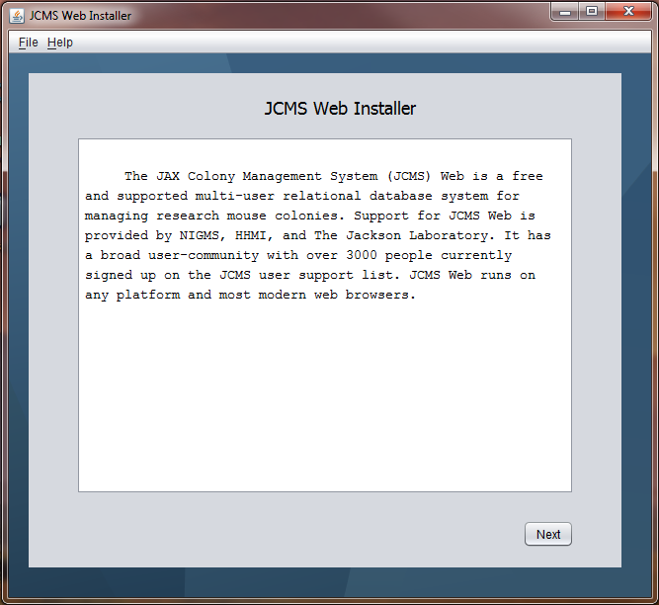

Figure : JCMS Web Installer

General information click next button to continue.

## Step 5: JCMS Web Installation Type

Select a new installation or upgrade. New installation installs JCMS Web over a previous version or a new location. All new installations prompt for a new database name. JCMS Web Installer requires proper installs of JAVA and MySQL Community Server before continuing any further with JCMS Web installation.

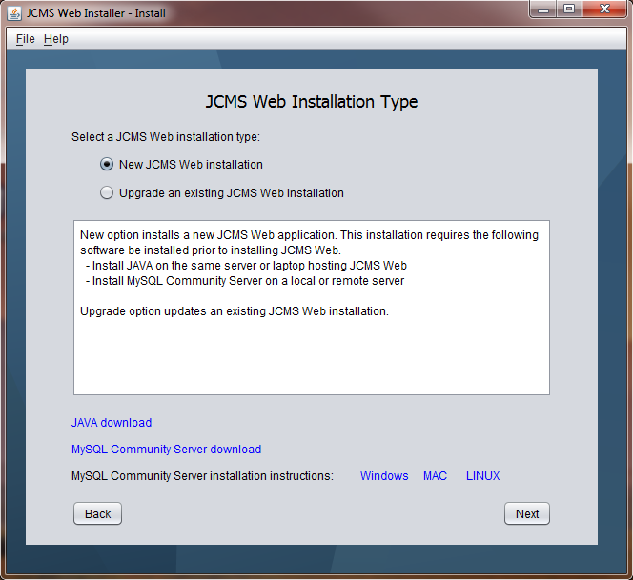

Figure : JCMS Web Installation Type

## Step 6: Install MySQL Community Server

Shows where MySQL Community Server can be downloaded from and how to configure it. MySQL must be installed before proceeding to the next step.

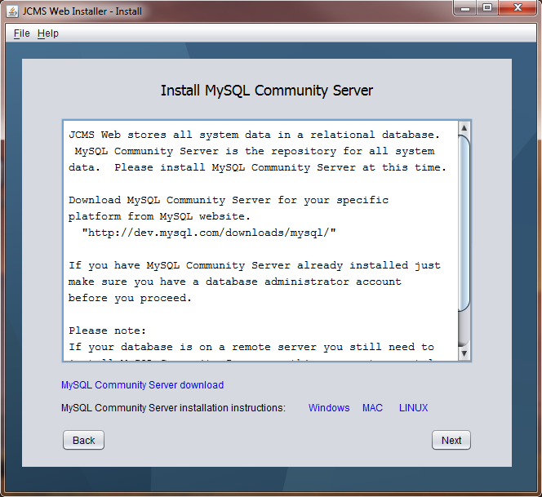

Figure : Install MySQL Community Server

For advanced configurations where the database resides on a remote MySQL Community Server instance you still need a local MySQL Community Server installation to support database backup and recovery.

## Step 7: Configure MySQL Community Server

On Windows only, add MySQL bin directory to the system path. Click the link for step by step instructions.

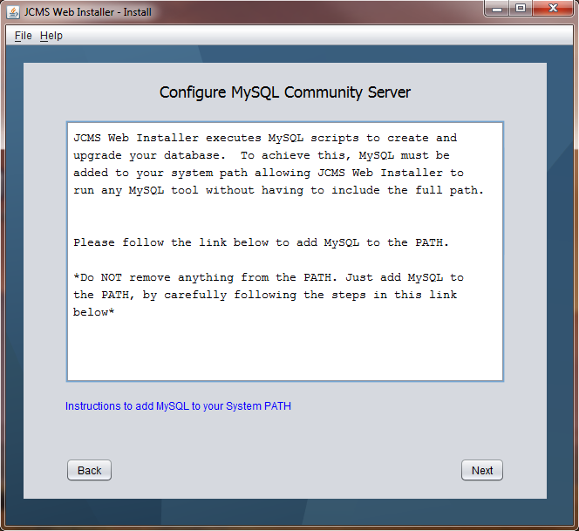

Figure : Configure MySQL Community Server

## Step 8: JCMS Web Setup

On this screen enter where you want to install JCMS Web, provide database administrator user name and password, a remote database administrator user name and password if your server is remote, and enter a unique database name for a new install.

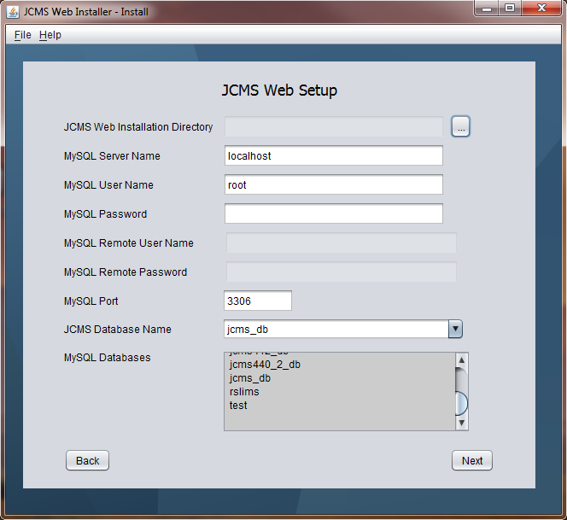

Figure : JCMS Web Setup

JCMS Web Installation Directory

This install directory is the location where the JCMS Software will reside. Later in this guide we will discuss how to start and stop the web application. The installation directory you select is very important so please keep track of it for future reference. For Windows computer we recommend the following install directory, C:\jcms\jcmsweb. Directory names should not contain any spaces. There is a known issue starting JCMS Web Application Server, JBOSS, when there are spaces in the install directory name.

MySQL Server Name

JCMS Web is a java web application that talks to a MySQL database to store and retrieve your data. The JCMSWeb Installer automates a bunch of configuration items that are necessary to make the software and database work together. The defaults are encouraged for the Port and Host unless you understand your configuration very well. The default user is the root who is the database super user or administrator. If you are not the admin for your database you will need to find a user and password that will allow you to create, manipulate tables and backup and recover JCMS database.

Any server name other than “localhost” indicates a remote database installation requiring a remote user name and password. Local database administrator user name and password is still required to properly backup and recover the original database if there is an installation issue.

MySQL User Name

MySQL administrator user name for the local database server, such as root.

MySQL Password

MySQL administrator password for the local database server.

MySQL Remote User Name

MySQL administrator user name for the remote database server when server name is not localhost.

MySQL Remote Password

MySQL administrator password for the remote database server when server name is not localhost.

MySQL Port

MySQL database server port. Default port is 3306.

MySQL Database Name

Enter a unique database name for JCMS Web. Refer to the current list of database to help eliminate entering a duplicate database name.

On update, select a database from this drop down list to upgrade.

MySQL Databases

Connects to the destination database server displaying all the current databases excluding MySQL system databases and the obsolete JCMS Web database, jcmsweb_db.

## Step 9: Installing JCMS Web

In the process of verify the configuration and adding the necessary data you will be presented with a list of Success, Info, Warn and Error messages. The following gives a general idea about the type of messages.

* SUCCESS

The installer attempted to change your system or tested a mandatory configuration, SUCCESS is the positive response.

* INFO

The installer will post many message to the log windows about your configuration. These INFO messages are logged when the configuration point was correct.

* WARN

The installer will post messages when there are concerns of the configuration. This configuration may or may not affect your system but it is a concern.

* ERROR

The installer issues ERROR message if it is unable to verify a specific configuration or it is unable to configuration the system.

During the installation process, if the JCMS Web Installation Directory is the location of a previous JCMS Web installation, you are prompted continue the installation or stop. Selecting yes to continue overwrites the previous JCMS Web installation with this new one.

All original databases and previous JCMS Web installations are backed up prior to an upgrade. If for any reason the installation fails all databases and installations are returned to their original state. Keep all logs in case more support is needed.

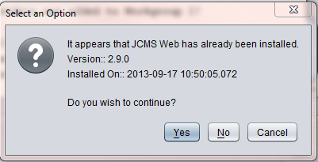

Figure : Select an Option

On completion of the installation the application will look similar to this

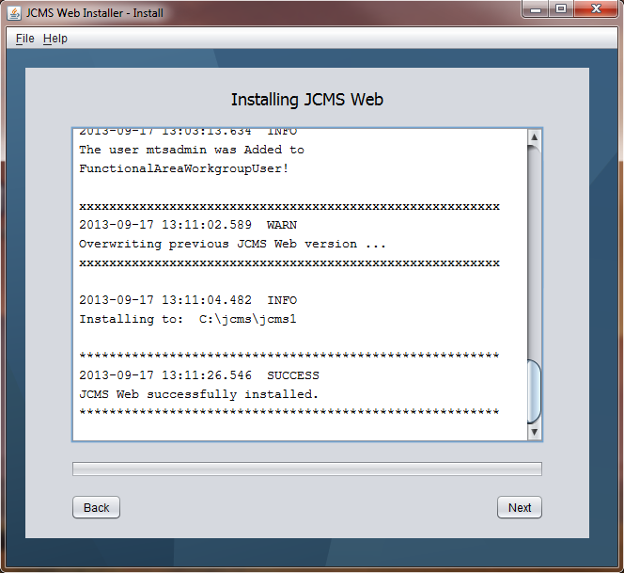

Figure : Installing JCMS Web

All the messages in the log window are writing to a log file in the JCMS Web Installation Directory.

## Step 10: JCMS Web Application Server

This page contains instruction on how to start JCMS Web Application Server. The application server must be running to open JCMS Web from a browser. Closing the command window or terminal window that start JCMS Web Application Server also stops JCMS Web. Please take note the instructions do change from Windows to MAC to LINUX. The following figure shows instructions for starting the application server from Windows. Although if one selects the quick start button named “Start JCMS Web Application Server”:

* On Windows, a command window will automatically open up minimized and start the application server
* On MAC and LINUX, the application server will start in the background.

Wait at least 2 minutes for the application server to start before clicking the link to open JCMS Web.

Don’t forget to click Next to review a list of resources and Close on the next screen to see a helpful quick start guide.

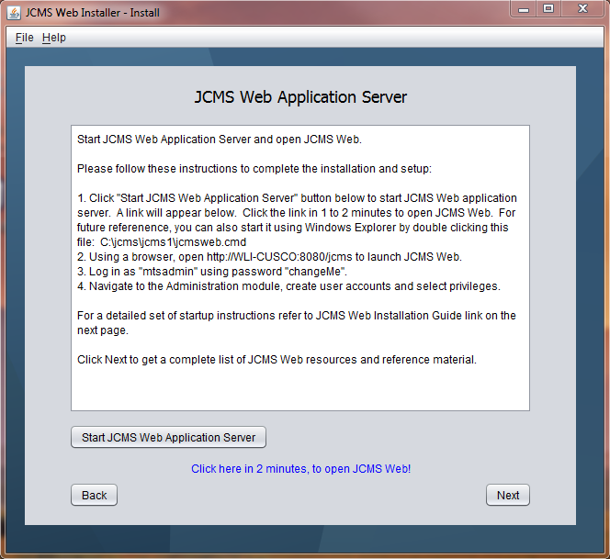

Figure : JCMS Web Application Server

## Step 11: JCMS Resources

This screen contains many if not all links to JCMS resources. After clicking Close a quick reference guide is copied to the Desktop and automatically opened in the browser.

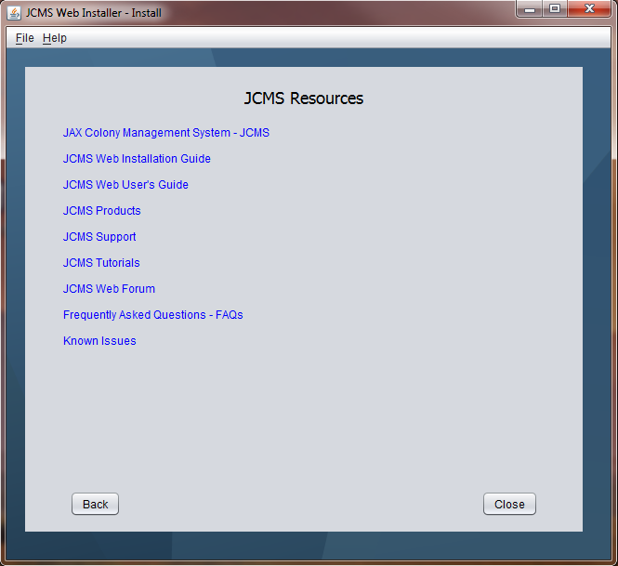

Figure : JCMS Resources

## Starting and stopping JCMS Web

**For Windows Users:**

Once the install application has configured the database and extracted the web application you will find command file in the destination directory called jcmsweb.cmd. The script starts the web application in a minimized command window. Leave this command window open.

**For MAC and LINUX Users:**

To start JCMSWeb double click on jcmsWeb.command, you will see a terminal open and JCMSWeb starting up.

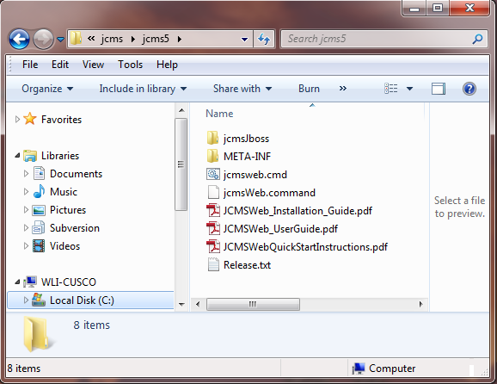

Figure : JCMS Web Command Files

To stop the JCMS Web application server, simply close the command window.

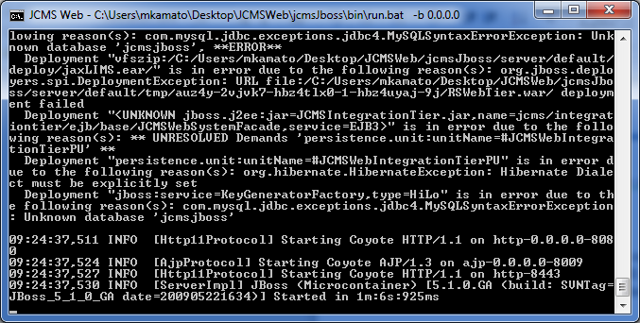

Figure : A JCMS Web Command Window

Feel free to create a short cut of this command file for ease of starting the web application. Once the application has been started it will take a minute for the application to be available. Navigate to the following link to see to view the web application.

On the same computer as the JCMS Web installation browse to

<http://localhost:8080/jcms>

For remote users have them browse to this URL substituting {hostname} with the name of the computer JCMS Web is installed on.

http://{hostname}:8080/jcms

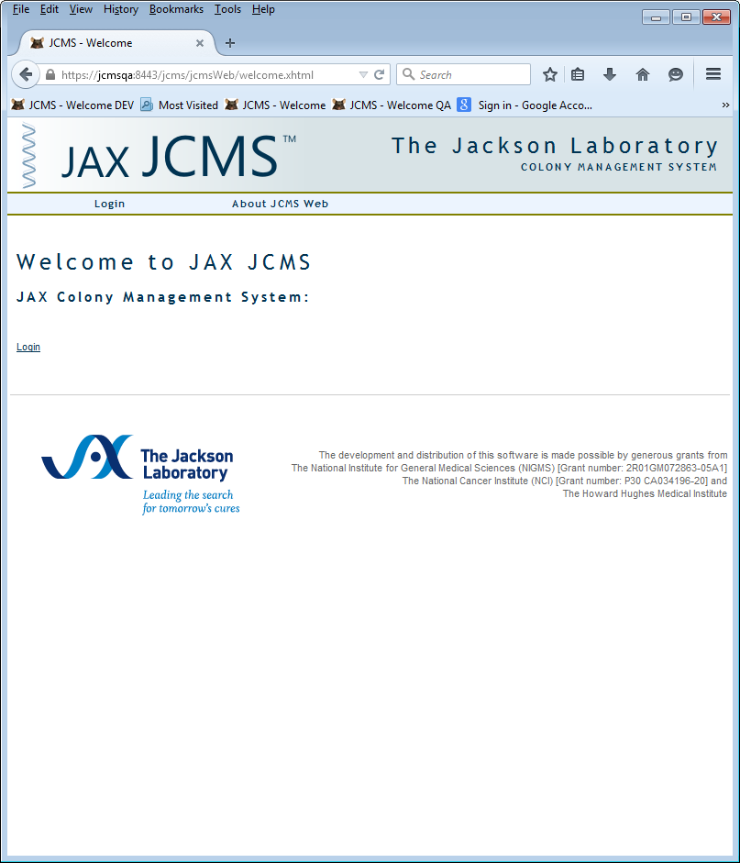

Figure : JCMS Web Welcome Page

## Getting started with the JCMS-Web application

The administrator login for the web application is mtsadmin. Clicking on the login brings you to the login screen. However when you do this you will get this screen. This is basically stating that you have not setup you web server to work on the internet. Since we are using as a local setup we can simple say continue and accept credentials permanently. JCMS Web is distributed with a self-signed certificate so that all users using JCMS Web can remain calm knowing all communication is encrypted.

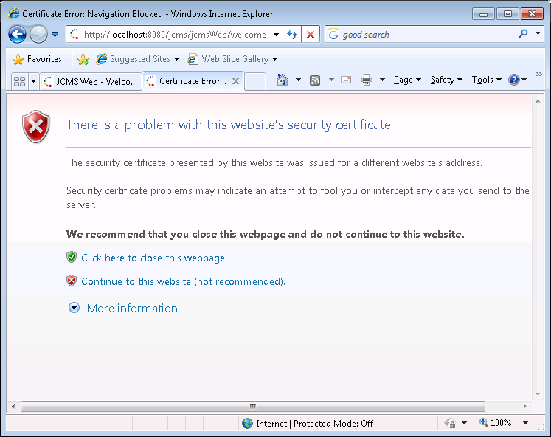

Figure : JCMS Web Accept Security Certificate

Supplying these credentials will get you started.

Username: mtsadmin

Password: changeMe

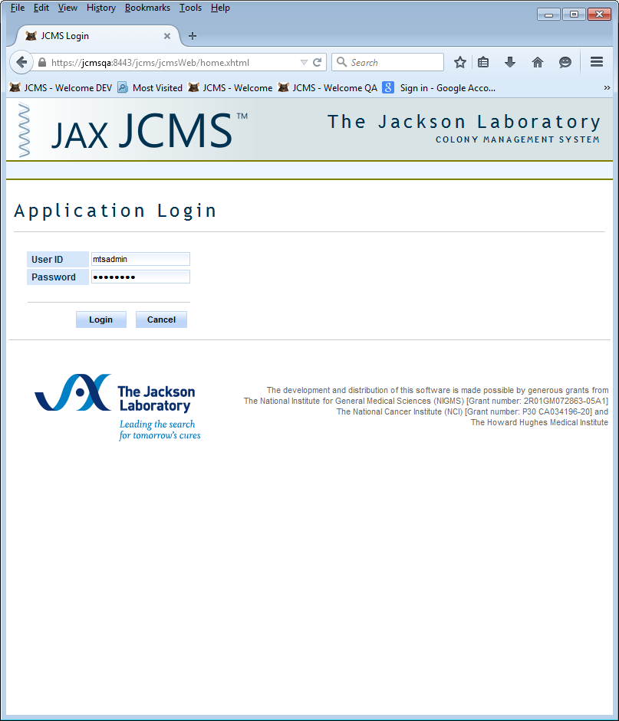

Figure : JCMS Web Application Login

Once you have logged in you will come to the home page.

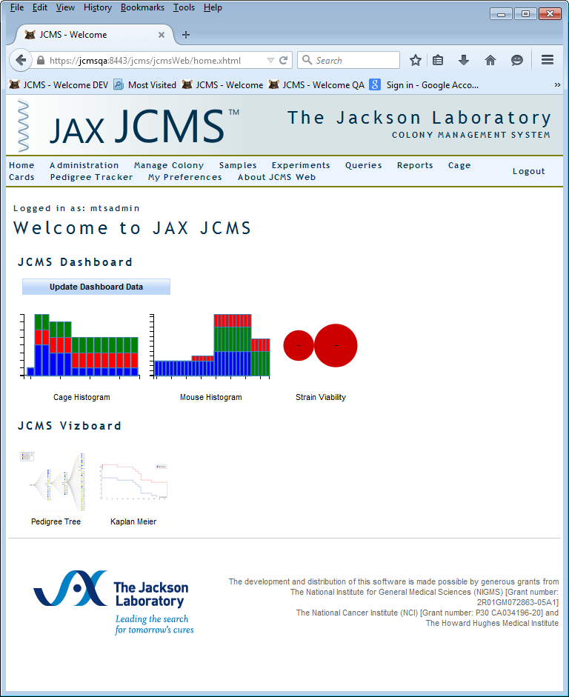

Figure : JCMS Web Home Page

Refer to JCMS User’s Guide for detailed instruction on how to use JCMS Web.

<http://colonymanagement.jax.org/products-2/jcms-web/>